**Restaurant Guide**

**Application functionality:**

1. Login
2. Logout
3. Guest Registration
4. Registration Close
5. Create Order
6. Fulfil Order
7. Order Payment
8. Menu Maintenance
9. Restaurant Maintenance

**Technologies:**

1. Asp .Net Core ( .NET CORE 3.1)
2. ASP .Net Core Identity
3. EF Core
4. gRPC
5. HTTP
6. Kestrel
7. MySQL
8. Docker
9. Socket Communication (for custom correlation example)
10. AppDynamics

**Architecture:**

Each domain field has its own microservice, e.g Order Fulfilment, Administration, etc. Communication is primarily done via gRPC, but in some cases it’s going to be the HTTP or Socket as some legacy applications are using direct connections.

**Services:**

1. Gateway (router for the client requests )
2. Administration
3. Order Fulfilment
4. IDP (Identity Provider, for the authorization purposes)

**AppDynamics schema**:

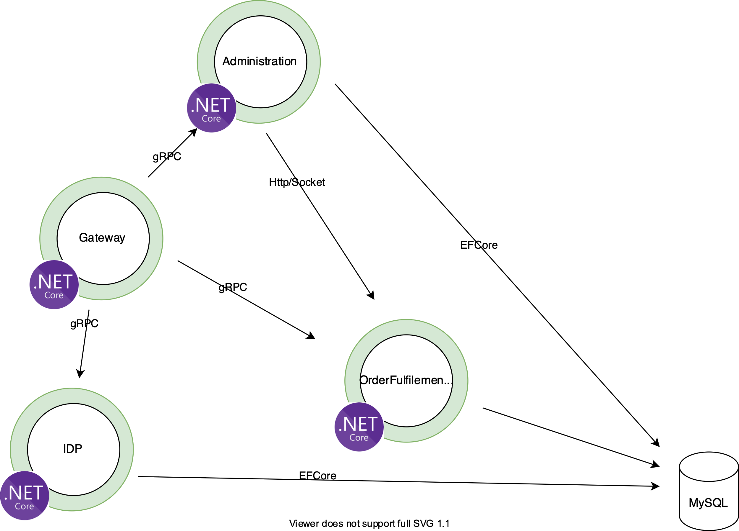

Everything is going to be hosted on single Cloud Machine large instance (docker containers)

**Monitoring topics that will be covered:**

1. .Net Core for Linux agent deployment and configuration on containers
2. Custom business transactions correlation using .Net Core agent SDK
3. Data Collectors (?)